

Sri Lanka Institute of Information Technology

**`**

Project Proposal

Information Technology Project (IT2080)

2018

ITP-2018-MLB-G1-08

Submitted by:

1. IT17042352 – (P.P.G.S.H.A.Guruge)

2. IT17052498 – (Jayawardena J.K.S.L)

3. IT17051644 – (Illandara T.S)

4. IT17048088 – (Nirathanka O.R.M)

5. IT17024464 – (Perera D.J.R)

6. IT16037816 – (Weerasooriya M.N.H)

7. IT16003606 – (Serasinghe N.H)

8. IT17028288 – (B.R.I.S Gunatileka)

Submitted to:

…………………………..

(Supervisor’s signature)

<<2018.07.>>

Introduction

Orocare is a Toothpaste Company which has started recently. Since the company has started in small scale, every part of the company’s business is managed manually.

The following company has now been gradually expanded and the company finds difficulty in handling company’s work manually. One of the major problems faced by the company is that the client, the owner of the company receives sales details at the end of the week by his sales representatives. The client get updates of his sales occasionally.

In order to succeed with their expansion, Orocare is in a need for automated system and is looking for IT services firm to perform the following:

* Automate company’s employees details.
* Automate company’s products details.
* Automate company’s suppliers details.
* Automate company’s stocks details.
* Automate company’s salaries details.
* Automate company’s orders details.
* Automate company’s sales details.

The solution proposed by us as IT students is to develop a system that fulfills main aspects of the company’s management. The proposed system :

* Stock Management
* Customer Management
* Product Management
* Finance Management
* Utility Management
* Employee Management
* Sales Management
* Employee Salary Management
* User management
* Supplier Information Management
* Supplier Order Management

The following management systems ensures that the company’s details are managed, manipulated automatically. Specially the system will keep the staff frequently updated

The benefits of the following system are:

* The client receives frequent sales information about his company
* Concurrent access to database and real time information
* Reduction of duplicated data

System Overview

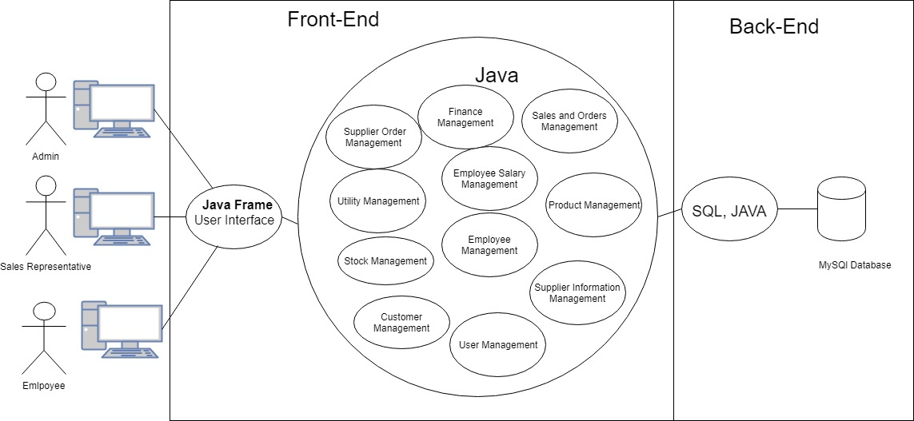

High level system overview diagram

The language used for developing the system is java, the other technologies used are java frames, sql, mysql. The system is developed as standalone system which is supposed to deployed on client’s computer.

In the above diagram an overview of the system is show in simplest form.There are different user levels in the system;

* The admin has the access to all the mentioned managements systems
* The Sales Representative has the access only to the Sales Management, Employee Salary Management and User Management.
* The Employee has the access only to the Employee Salary Management and User Management.

Since the admin cannot handle all the management systems concurrently he can give access to employees as he desire.

All the users in the system deals with the system via the User Interface which is designed using Java Frames, and all the core modules of the system are connected to the database.

User Management

* This module is the main module in the system.
* One of the main tasks of this module is to give different user levels for users. The admin is capable of granting permission to users according to his desire.
* Functions such as registering users, login include in this module.
* An Employee of the company can login to the system using his NIC and Employee ID.
* If the Admin wishes to give permissions to an employee, the employee should submit a request to the admin, and upon the approval of the admin the employee can access restricted modules.
* A user can maintain his personal details and update them according to his wish.
* In case if the user resigns from the company the user can deactivate his user profile or the Admin can disable the user.
* Admin also can track user activities such a logged in time, logged out time.

Customer Management

* This module maintains the customers’ information of the company.
* The main function of this module is to keep track of the customers by inserting

records of the new sales of the company into the system.

* In addition to inserting new customers, the user can also update the existing records if any change has to be made due to various reasons.
* Due to any reason customers can also be removed from the database

Stock Management

* Stock Management System is one of the main subsystems of the system.
* The main function of this module is to keep track of the stock by inserting

records of the items of the company into the system.This is been done by a valid privileged user.

* In addition to inserting new records, the user can also update the existing records if any change has to be made due to various reasons.
* The user can also delete the unwanted stock item records if needed.
* The stock information viewing function is also included to view the new and updated item records when needed.
* All the stock item records are been stored in the system database.
* In this function, the user would be able to keep records off all the information on each item such as quantities, their expiry dates, manufacturers, prices, etc.
* The user will be notified, if the items of the stock is running out (getting low in quantities).
* Finally the user can be able to take a report of the stock management of its company including all of its details.

Product Management

* Product Management System is one of the main subsystems of the system.
* The main function of this module is to keep track of the Product details by inserting

records of the products, which is produced by the company into the system.This would be done by a valid privileged user.

* In addition to inserting new records, the user can also update the existing records if any change has to be made due to various reasons.
* The user can also delete the unwanted or old product detail records if needed.
* The product information viewing function is also included to view the new and updated product detail records when needed.
* All the product item records are been stored in the system database.
* In this function, the user would be able to keep records off all the information on each product such as name, ingredients, price, etc.
* Finally the user can be able to take a report of the items management of its company including all of its details.

Finance Management

* This module is responsible for calculating income and expenses of the company monthly
* Saving income and expenses in the database monthly

Sales Management

* This module maintains the sales information of the company.
* The main function of this module is to keep track of the sales by inserting

records of the new sales of the company into the system.

* Orders are also maintained as a sub function of this module.
* Sales of the company are divided into two types as external and internal

sales.Internal sales are sales done at the company itself.Customer is required

to arrive at the company for this.External sales are done by the sales

representatives by travelling to locations such as retailer shops and taking

orders for the required product.

* External sales orders will have to be confirmed later by the customers and the

sales records will be updated after the payment is made only.This is not required

for internal sales as the order and payment are done at the same time.

* In addition to inserting new records the sales representative can also update

the existing records if any change has to be made due to various reasons.

* The sales representative can also delete the unwanted sales records if needed.
* A sales viewing function is also included to view the new and updated sales

records when needed.

* All the sales records are been stored in the system database.
* Database keeps record of information such as ID,type,price,quantity of the

product sold.

Order Management

* This module maintains the order information of the customers.
* The main function of this module is to keep track of the orders made by the customers. This is done by inserting records of the orders placed by the company into the system.The supplier order management representative is responsible for inserting the records of the orders.
* In addition to inserting new records the order management representative can also update the existing records if any change has to be made due to various reasons.
* The order management representative can also delete the unwanted order records if needed.
* A order viewing function is also included to view the order records when needed.
* All the order records are been stored in the system database.
* Database keeps record of information such as order ID, product ID, product name, order date, unit price of product, no. of items ordered, discounts, total price of the order.

Employee Salary Management

* The main function of this module is to keep and manipulate the salary details of all employees by inserting records of the employees and their salary details including EPF, ETF, other funds into the system.This is been done by a valid privileged user.
* In addition to inserting new records, the user can also update the existing records if any change has to be made due to various reasons.
* The user can also delete the unwanted records if needed.
* Employee salary information viewing function is also included to view the new and updated records when needed.
* All the salary records of employees are been stored in the system database.
* Finally the user can print a salary slip and view salary reports.

Utility Management

* This module is responsible for keeping records of utility bills of the company and manage them
* These records can be viewed, updated, deleted or added when necessary

Supplier Information Management

* The main function of this module is to keep and manipulate the Supplier Information details of all suppliers by inserting records of the suppliers.
* In addition to inserting new records, the user can also update the existing records if any change has to be made due to various reasons.
* The user can also delete the unwanted records if needed.
* Supplier information viewing function is also included to view the new and updated records when needed.
* Supplier records of employees are been stored in the system database.

Employee Management

* This module maintains the employers’ information of the company.
* The main function of this module is to keep track of the employees by inserting

records of the new recruited employees of the company into the system.This is been done by the staff manager.

* In addition to inserting new records the staff manager can also update

the existing records if any change has to be made due to various reasons.

* The staff manager can also delete the unwanted sales records if needed.
* All the sales records are been stored in the system database.

Supplier Order Management

* This module maintains the Supplier order information of the company.
* The main function of this module is to keep track of the supplier orders made by the company. This is done by inserting records of the orders placed by the company into the system.The supplier order management representative is responsible for inserting the records of the orders.
* In addition to inserting new records the supplier order management representative can also update the existing records if any change has to be made due to various reasons.
* The supplier order management representative can also delete the unwanted order records if needed.
* A supplier order viewing function is also included to view the order records when needed.
* All the supplier order records are been stored in the system database.
* Database keeps record of information such as order ID, supplier ID, supplier name, order date, material name, unit price of material, no. of items ordered, discounts, total price of the order.

Gantt chart

|  |  |  |  |
| --- | --- | --- | --- |
| Task | Start Date | End Date | Duration |
| Gather Requirements | 14-Jun-18 | 02-Jul-18 | 16 |
| Project Proposal | 03-Jul-18 | 15-Jul-18 | 12 |
| Interface Designing and Paper Prototyping | 16-Jul-18 | 20-Jul-18 | 4 |
| Documenting | 21-Jul-18 | 24-Jul-18 | 3 |
| Coding | 25-Jul-18 | 05-Aug-18 | 10 |
| Testing | 06-Aug-18 | 09-Aug-18 | 3 |
| Final Report | 06-Aug-18 | 14-Aug-18 | 4 |

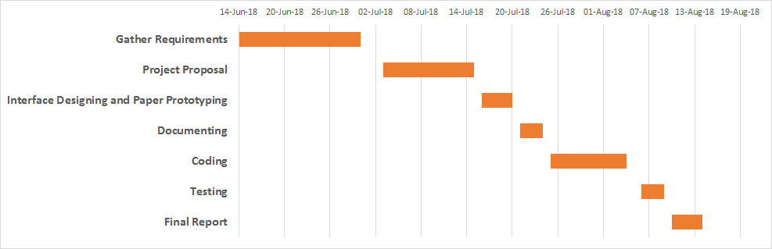

**Work breakdown structure**

|  |  |  |
| --- | --- | --- |
| Function | Registration No | Name |
| User Management | IT17042352 | P.P.G.S.H.A.Guruge |
| Stock Management, User login | IT17052498 | Jayawardena J.K.S.L |
| Product Management | IT17048088 | Nirathanka O.R.M |
| Sales Management | IT17051644 | Illandara T.S |
| Employee Salary Management | IT17024464 | Perera D.J.R |
| Employee Management | IT16037816 | Weerasooriya M.N.H |
| Supplier Information Management | IT16003606 | Serasinghe N.H |
| Order Management | IT17028288 | Gunatileka B.R.I.S |